INTRODUCTION:
- The Internet of things (IoT) is a system of interrelated computing devices, mechanical and digital machines, objects, animals or people that are provided with unique identifiers and the ability to transfer data over a network without requiring human-to-human or human-to-computer interactions.
- The Internet of Things thus promises a strong added value to each domain.
- By connecting objects, people and environments, it becomes possible to develop improvements that can only be beneficial.
- As we all know the term IOT that is internet of things which is designed to save time and for making work easy and accurate.
- As far as time and security is concern with the help of IOT we will build a cradle system which will make parents stress free and most important it will be safe and secure for the baby.
- So, managing the work in time and taking care of baby is very important factors. Cradle system will give parents required time to parent for rest, as if the parents both mother and father goes for the job or even if the mother is house wife.
- Being stress free will definitely create the great atmosphere which will make great atmosphere around the baby.
- So, it doesn’t matter if there is no one to swing cradle it will do swing automatically if the baby is crying.
- It doesn’t matter if baby has done pee and no one knows about for long time, but not need to worry cradle system will also give the alert about the wetness in cradle.
- Also, if baby is getting fever or cold Cradle system also have the ability to detect it and send the alert.
- Our cradle will also able to detect if any motion in the cradle by motion sensor for security purpose of the baby.
- Proposed system will help the parents, so that they can take good care of their baby.

Components used in the project:

- Arduino Uno Microcontroller :
Arduino Uno is one of the most commonly used hardware in the Arduino series. It is low cost, easily available and is quite compact. It has an on-board USB to serial chip so we can easily load code into the on-board at mega328 controller. Fig. Arduino Uno Microcontroller .

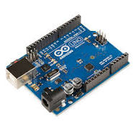

2. GSM Module : This GSM modem has a SIM800A chip and RS232 interface while enables easy connection with the computer or laptop using the USB to Serial connector. SMS can send and receive using AT command.

3.Gear Motor:
In this system the gear motor is used for swinging the cradle. Since gear motor converts the electrical power into mechanical power. The motor starts swinging when baby starts crying.

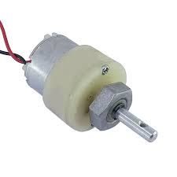

Fig. Gear Motor

4. LM 35: Temperature sensor is used in this system to provide the data about baby’s body temperature.

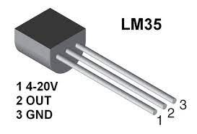

Fig. LM35

5. PIR: The PIR sensor is used for motion detection. It is used to detect a moving object particularly people.

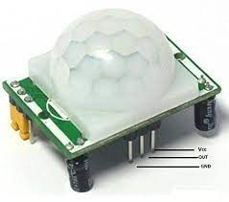

Fig. PIR Sensor
6. Wetness Sensor: Wet sensor is used for finding wetness. If the baby wets the cradle then the sensor indicates it.
Fig. Wetness Sensor
7. DHT -11: DHT11 is the basic temperature module and humidity sensor module with digital output at low cost. It will update regarding room temperature.
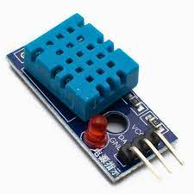
Fig. DHT 11
8. Sound Sensor: This is a very easy to use Sound Detection Sensor module. This sensor will able to capture the sound of baby.
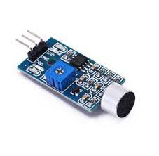
Fig. Sound Sensor

ADVANTAGES:
- Cost efficient
- User friendly
- Ensures safety
- Minimum manual work
- Baby sooth comfortably
- Baby stays healthy
CONCLUSION :
Growth of technology has been rapidly increased. Since technology has been developed greatly it can contribute to the society in various way. Automated cradle is the best example where working parents have lot of workload already and they have to care of baby as well. Cradle system assures them that their baby is safe and secure inside the cradle. Cradle which is less expensive and more secure and have more features. As health of small baby is always factor for which parents are always worried. So that cradle system is built for that purpose that baby will be healthier. This automatic baby cradle would let the working mother to do household works besides taking care of baby at the same time.
SOURCE CODE:
import RPi.GPIO as GPIO
import time

# Initialize GPIO pins
GPIO.setmode(GPIO.BCM)
wetness_sensor_pin = 17
GPIO.setup(wetness_sensor_pin, GPIO.IN)

def detect_wetness():
return GPIO.input(wetness_sensor_pin)

def main():
try:
while True:
wetness = detect_wetness()
if wetness:
print("Baby's bed is wet!")
# Send notification to the parent's app
# Implement camera capture and cry detection here
time.sleep(1)
except KeyboardInterrupt:
GPIO.cleanup()

if __name__ == "__main__":
main()

